Screen Shot Appendix

Testing Screen Shots

Unit Testing With JUnit

Entity Class
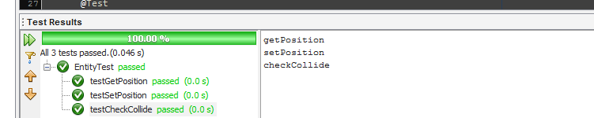
Highscore Class
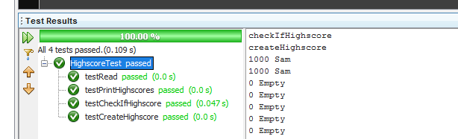

Hunter Class
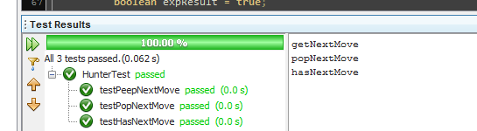

PathGen Class
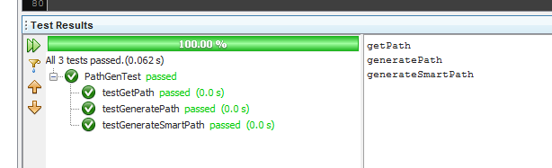

Player Class
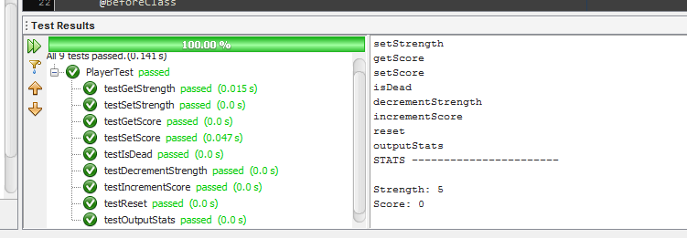
Point Class
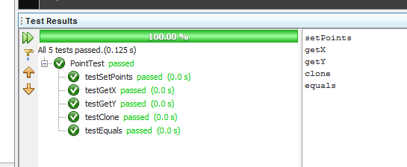

Square Class
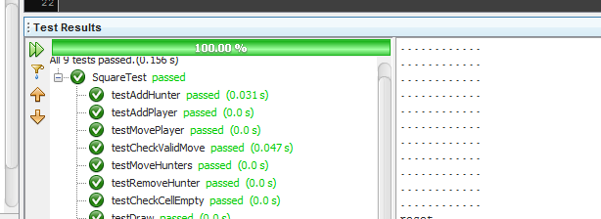

Game Class
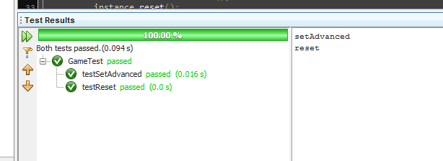

Testing the Whole Application
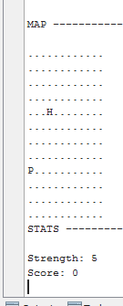Illustration 1: Moving the player around the grid.
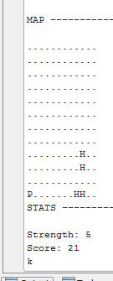Illustration 2: Multiple Hunters and the score incrementing
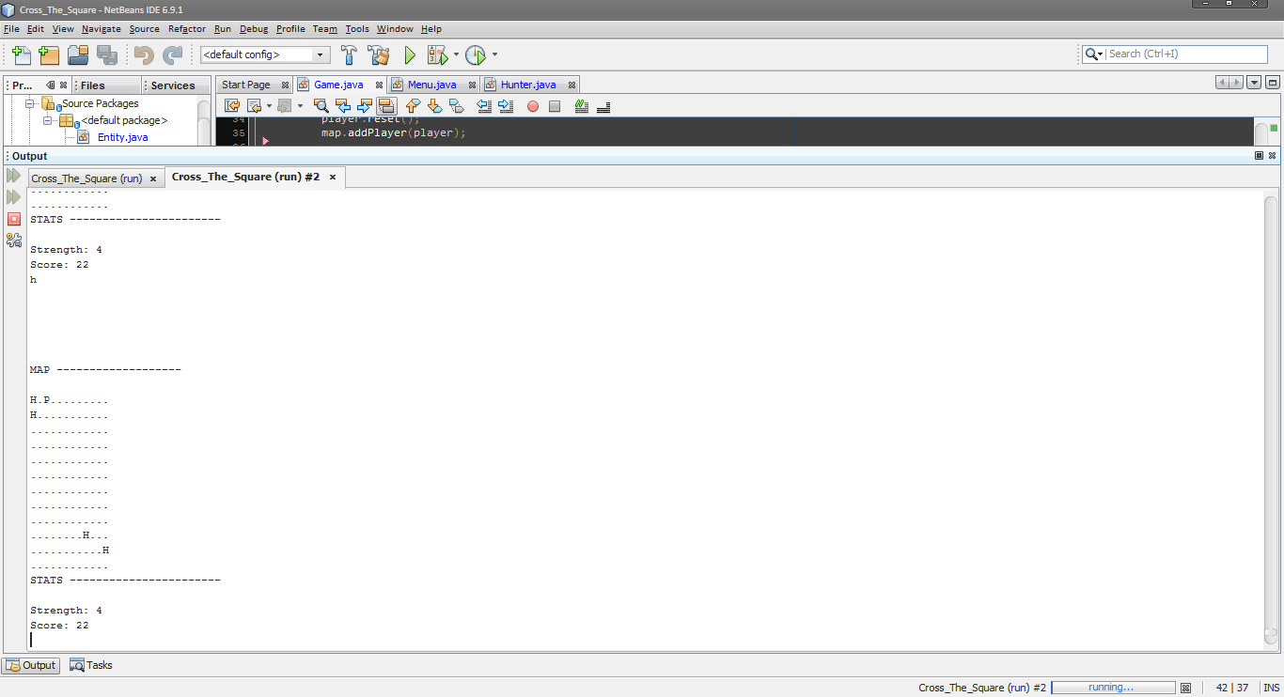Illustration 3: Strength being decreased after a collision.
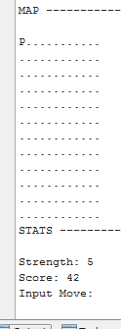Illustration 4: Changing level after a score of 42 is reached.
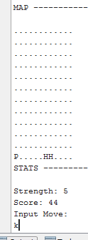Illustration 5: Hunters now head directly for the player.
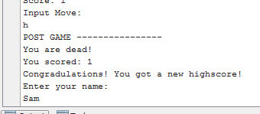Illustration 6: Post game asking for the users name for a new high score
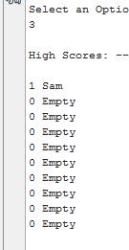Illustration 7: High scores being output to the console

